# CS 255 System Design Document Template

This template lays out all the different sections that you need to complete for Project Two. Each section has guidance to prompt your thinking. You will need to continually reference the interview transcript as you work to make sure that you are addressing your client’s needs. There is no required length for the final document. Instead the goal is to complete each section based on what your client’s needs are. Remove this note when you are finished, and replace all bracketed text with the relevant information.

## UML Diagrams

### UML Use Case Diagram

### UML Activity Diagrams

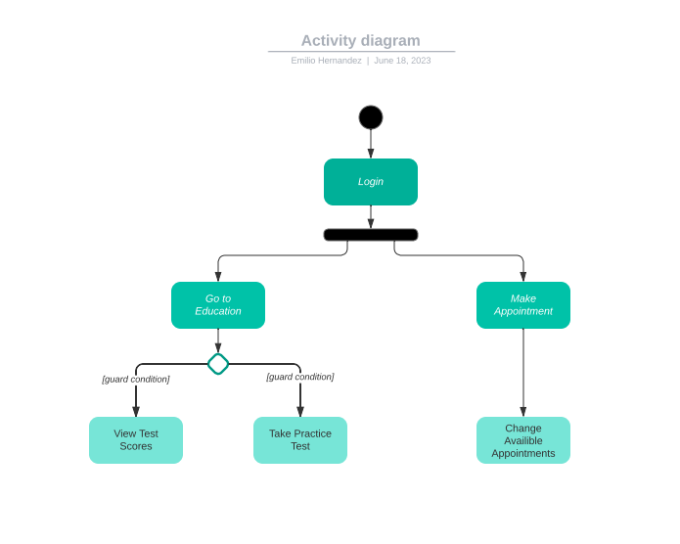

### UML Sequence Diagram

### UML Class Diagram

## Technical Requirements

*Based on the use cases that will be needed to complete all the required material it will need to be a cloud-based webpage. This will allow anyone with a computer to be able to work with the system and be able to fulfill the requirements needed. The system will also need to create a link to DMV information to allow users to study and be given correct information. The system needs to be secure by keeping passwords and user information private. This is even more important to differentiate customers from admin because admin will be able to delete and reset customer logins.*